**Indira Gandhi Delhi Technical University for Women**

**(Established by Govt. of Delhi vide Act 09 of 2012)**

**(Formerly Indira Gandhi Institute of Technology)**

**Kashmere Gate, Delhi - 110006**



**LABORATORY FILE**

**for**

**Web Technologies**

**MCA 207**

**Submitted by:**

**Submitted to:**

Ms. Ankita Singh Roopal Mittal

MCA, 3rd Sem

02004092019

**Date: 04-09-2020**

**LAB 5 WORK**

**Ques 10: Write a JavaScript code that illustrates the use of different native objects (Number, String, Maths, Date)**

**HTML + JS Code:**

<html>

<head>

<title>JavaScript Native Objects</title>

<style>

h2{

color: LightBlue;

}

div{

border: 2px solid;

padding-left: 300px;

padding-right: 300px;

}

</style>

</head>

<body bgcolor=black text=white>

<div>

<h2>JavaScript Number Methods</h2>

<p>The <b>toExponential()</b> method returns a string, with the number rounded and written using exponential notation.</p>

<p>An optional parameter defines the number of digits behind the decimal point.</p>

<i> var x = 3.1478;</i>

<p id="expo"></p>

<p>The <b>valueOf()</b> method returns a number as a number.</p>

<i>var x = 123;</i>

<p id="valueof"></p>

</div>

<br>

<div>

<h2>JavaScript String Methods</h2>

<p>The <b>length</b> property returns the length of a string.</p>

<i>var txt = "Roopal Mittal";</i>

<p id="length"></p>

<p>The <b>indexOf()</b> method returns the position of the first occurrence of a specified text.</p>

<i> var str = "Please locate where 'locate' occurs!";</i>

<i> var pos = str.indexOf("locate");</i>

<p id="index"></p>

<p>The <b>search()</b> method returns the position of the first occurrence of a specified text in a string.</p>

<i>var str = "Please locate where 'locate' occurs!";</i><br>

<i> var pos = str.search("locate");</i>

<p id="search"></p>

</div>

<br>

<div>

<h2>JavaScript Math Functions</h2>

The math object provides you properties and methods for mathematical constants and functions.

<p><b>Math.round(x)</b> will round off the value of x to the nearest value.</p>

<p>Math.round(10.8976)=</p>

<p id="round"></p>

<p><b>Math.pow(a,x)</b> returns a to the power x.</p>

<p>Math.pow(12,6)=</p>

<p id="power"></p>

<p><b>Math.sqrt(x)</b> returns the square root of x.</p>

<p>Math.sqrt(100)=</p>

<p id="sqrt"></p>

</div>

<br>

<div>

<h2>JavaScript Date Functions</h2>

<p>Using new Date(), creates a new date object with the current date and time.</p>

<i>var d = new Date();</i>

<p id="date"></p>

<p>Using new Date(with 7 parameters), creates a new date object with the specified date and time.</p>

<i>var d = new Date(2018, 11, 24, 10, 33, 30, 0);</i>

<p id="date1"></p>

<p>A Date object can be created with a specified date and time:</p>

<i>var d = new Date("October 13, 2014 11:13:00");</i>

<p id="date2"></p>

</div>

<script>

document.getElementById("round").innerHTML = Math.round(10.8976);

document.getElementById("power").innerHTML = Math.pow(12,6);

document.getElementById("sqrt").innerHTML = Math.sqrt(100);

var x = 3.1478;

document.getElementById("expo").innerHTML =x.toExponential() + ", " + x.toExponential(2) + ", " + x.toExponential(4) + ", " + x.toExponential(6);

var x = 123;

document.getElementById("valueof").innerHTML = x.valueOf() + ", " +(123).valueOf() + ", " +(100 + 23).valueOf();

var txt = "Roopal Mittal";

document.getElementById("length").innerHTML = txt.length;

var str = "Please locate where 'locate' occurs!";

var pos = str.indexOf("locate");

document.getElementById("index").innerHTML = pos;

var str = "Please locate where 'locate' occurs!";

var pos = str.search("locate");

document.getElementById("search").innerHTML = pos;

var d = new Date();

document.getElementById("date").innerHTML = d;

var d = new Date(2018, 11, 24, 10, 33, 30, 0);

document.getElementById("date1").innerHTML = d;

var d = new Date("October 13, 2014 11:13:00");

document.getElementById("date2").innerHTML = d;

</script>

</body>

</html>

**Output:**

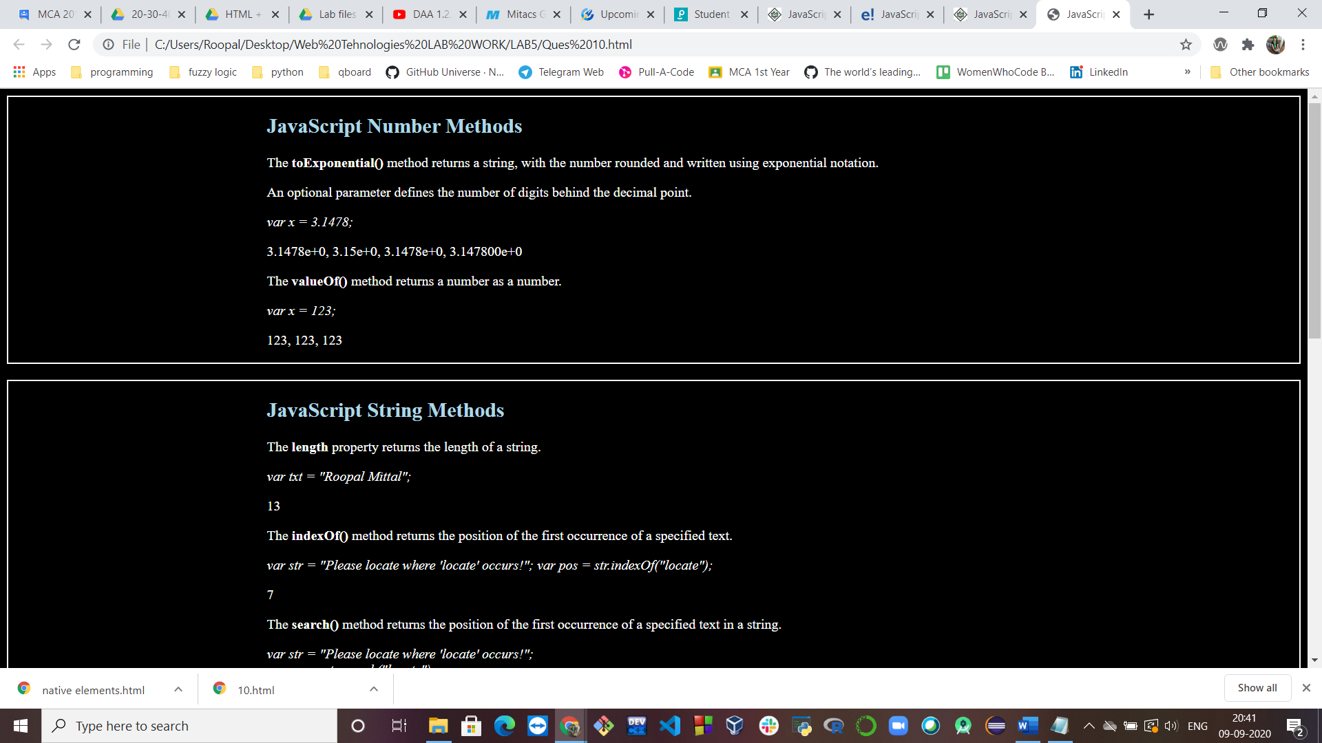

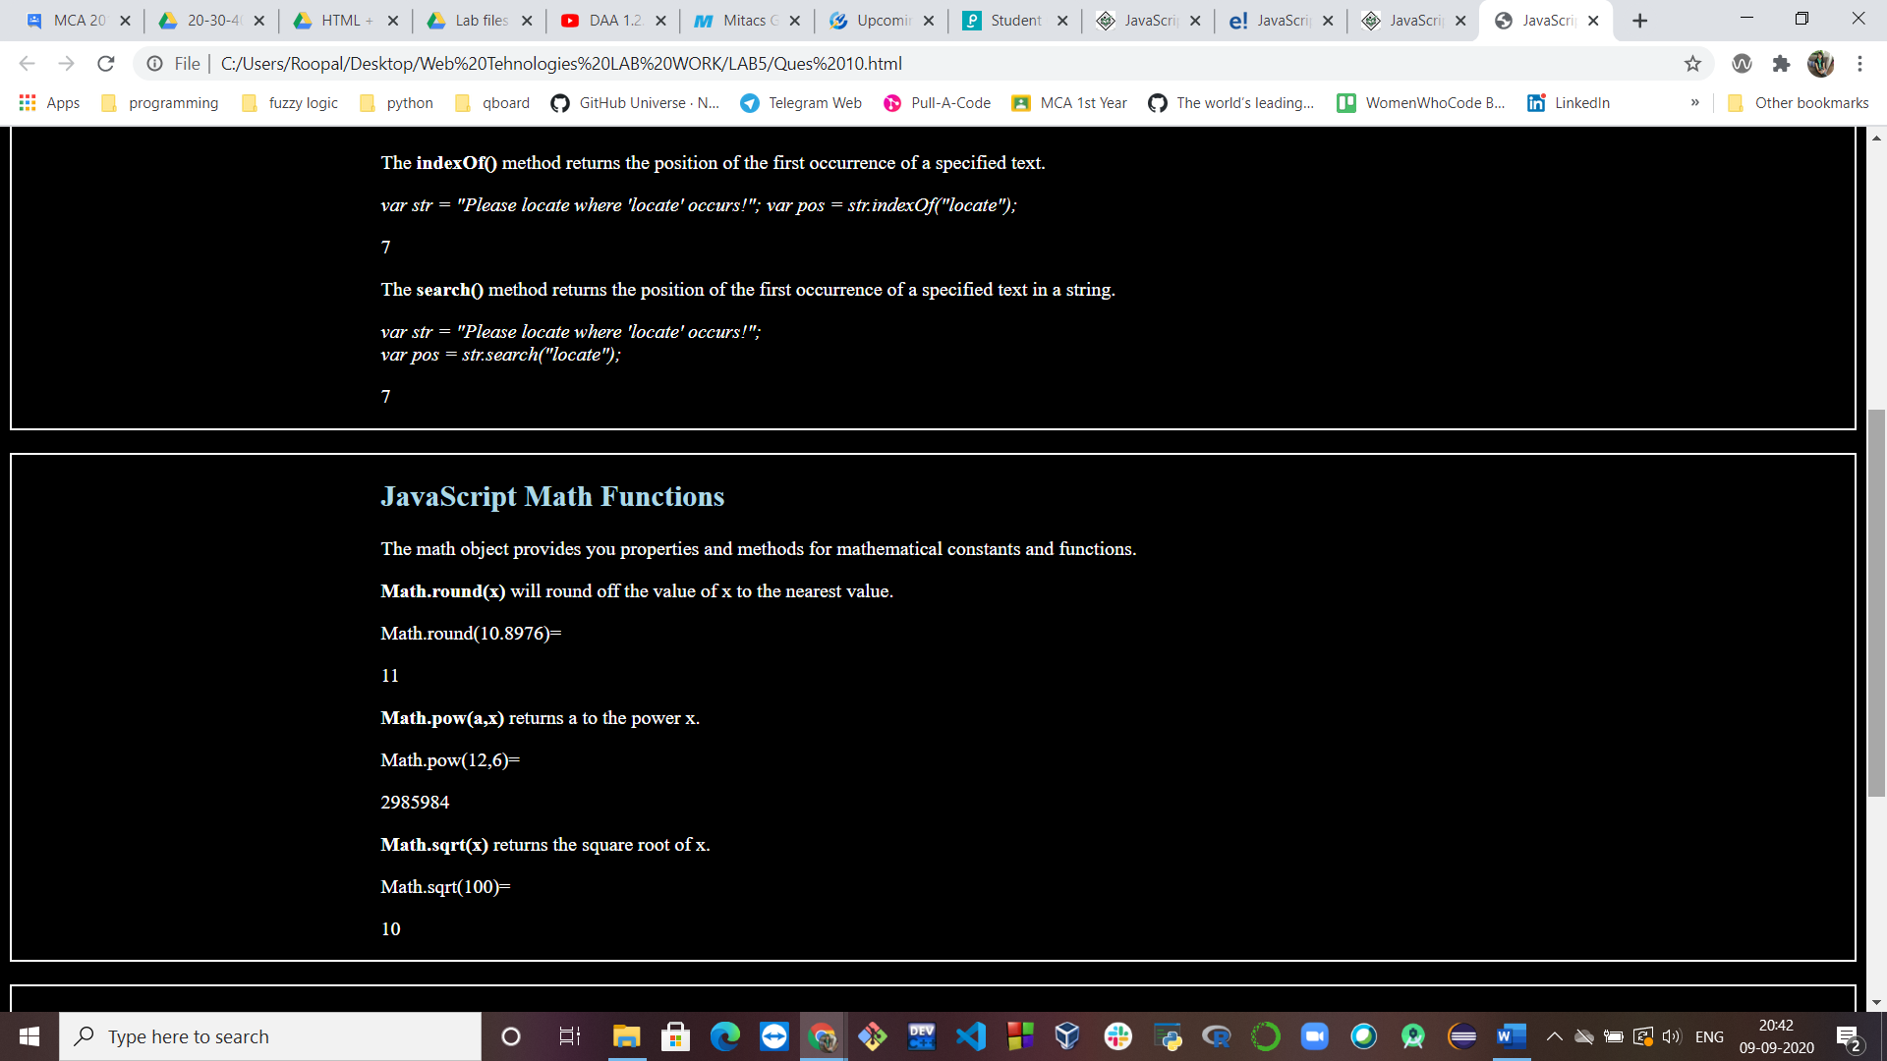

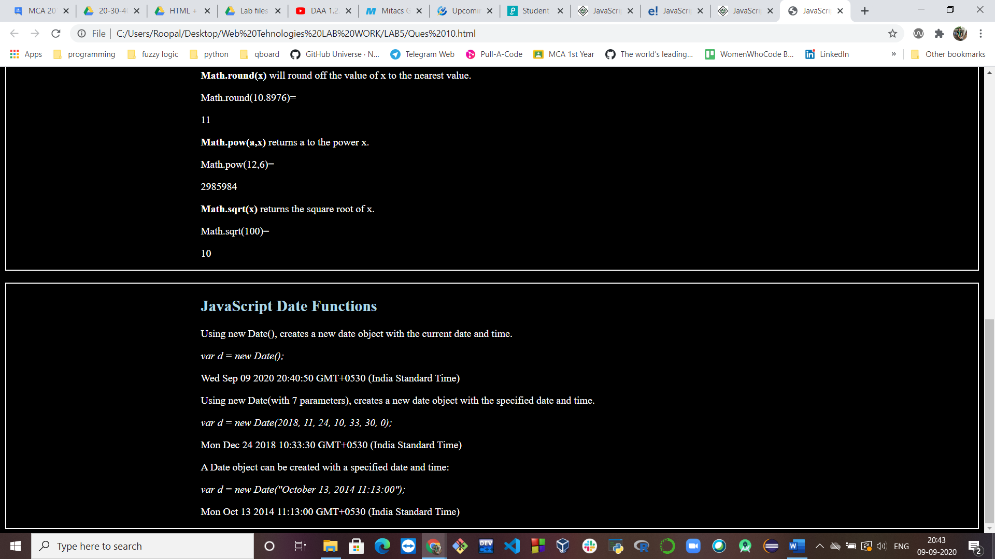

**Ques 11: Write a Java Script code to illustrate how to create user-defined objects.**

**HTML + JS Code:**

<html>

<head>

<title>User-defined objects</title>

<style>

h1{

color: Red;

}

</style>

<script type = "text/javascript">

var student = new Object(); // Create the object

student.name = "Roopal Mittal";

student.number = "02004092019";

student.course = "MCA";

</script>

</head>

<body bgcolor="LightGray">

<h1><b> User-Defined Objects</b></h1>

<script type = "text/javascript">

document.write("Student Name : " + student.name + "<br>");

document.write("Enrollemnt Number: " + student.number + "<br>");

document.write("Course: " + student.course + "<br>");

</script>

</body>

</html>

**Output:**

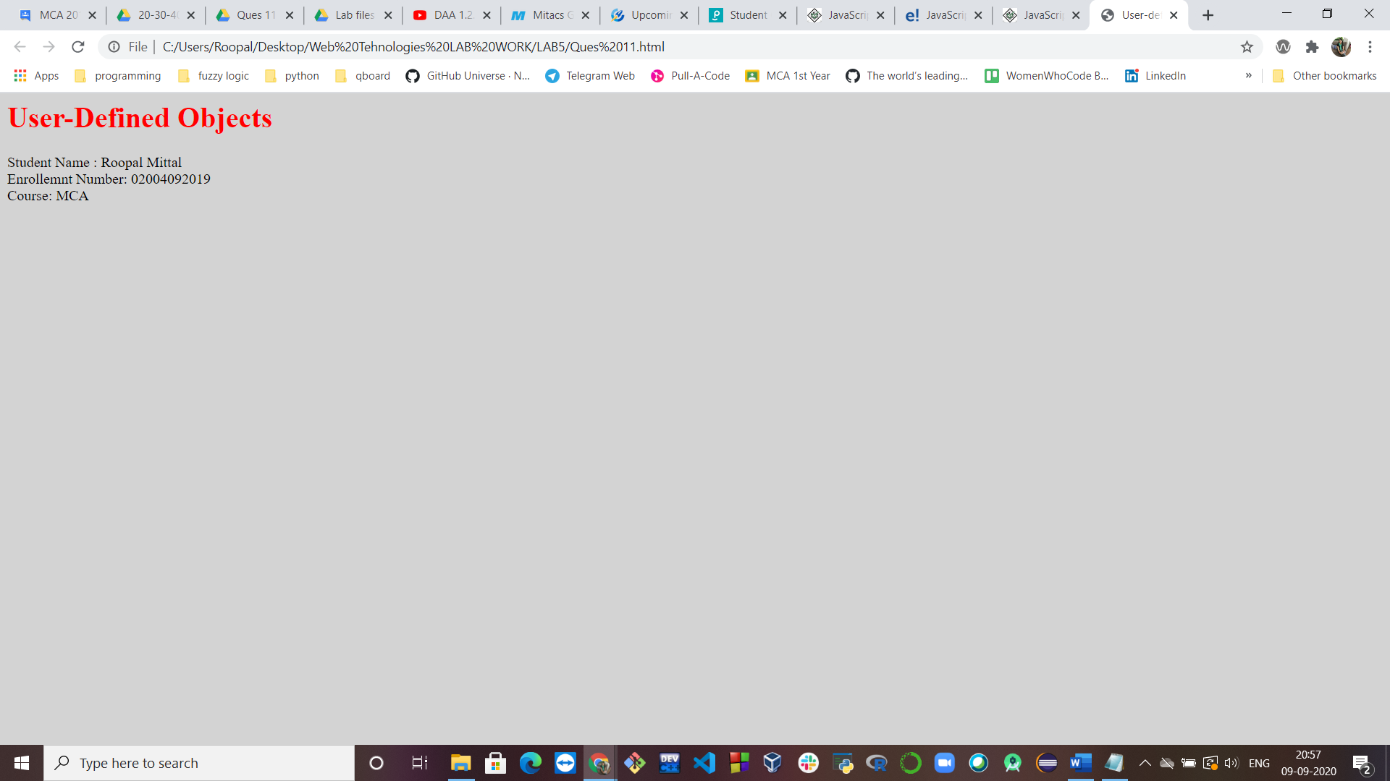

**Ques 12: Write a JavaScript code to illustrate the use of Hidden field.**

**HTML + JS Code:**

<html>

<head>

<title>Hidden Elements</title>

<style>

body

{

background-image: url(bg2.jpg);

}

</style>

</head>

<body>

<br>

<h1 style="color: white;">Example of Hidden Input Field</h1>

<input type="hidden" id="myInput" value=" Welcome to the world of secrets!">

<h2 style="color: white;">Click the button to see hidden text.

<br>This is implemented by getting the value of the hidden field.</h2>

<button onclick="yourName()">See Magic !</button>

<i id="magic" style="color: white;"></i>

<script>

function yourName() {

var x = document.getElementById("myInput").value;

document.getElementById("magic").innerHTML = x;

}

</script>

</body>

</html>

**Output:**

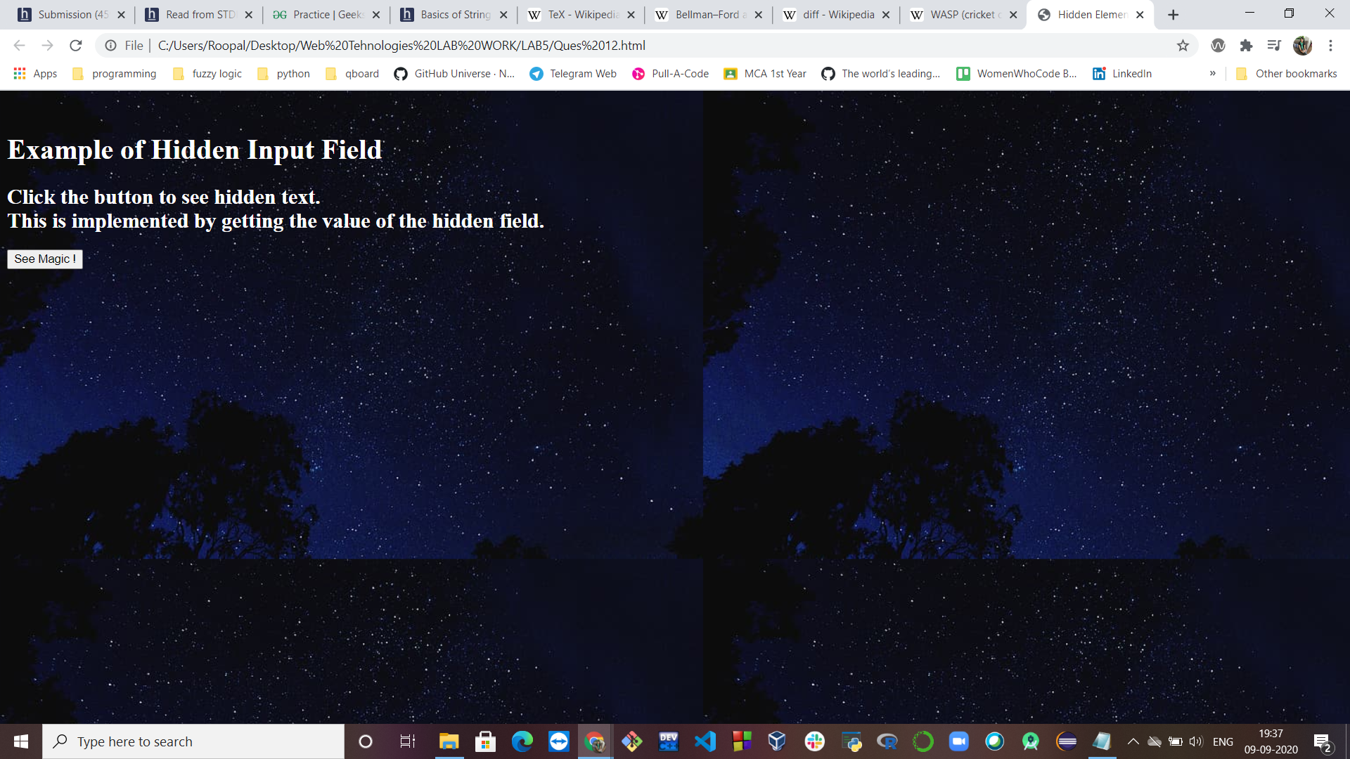

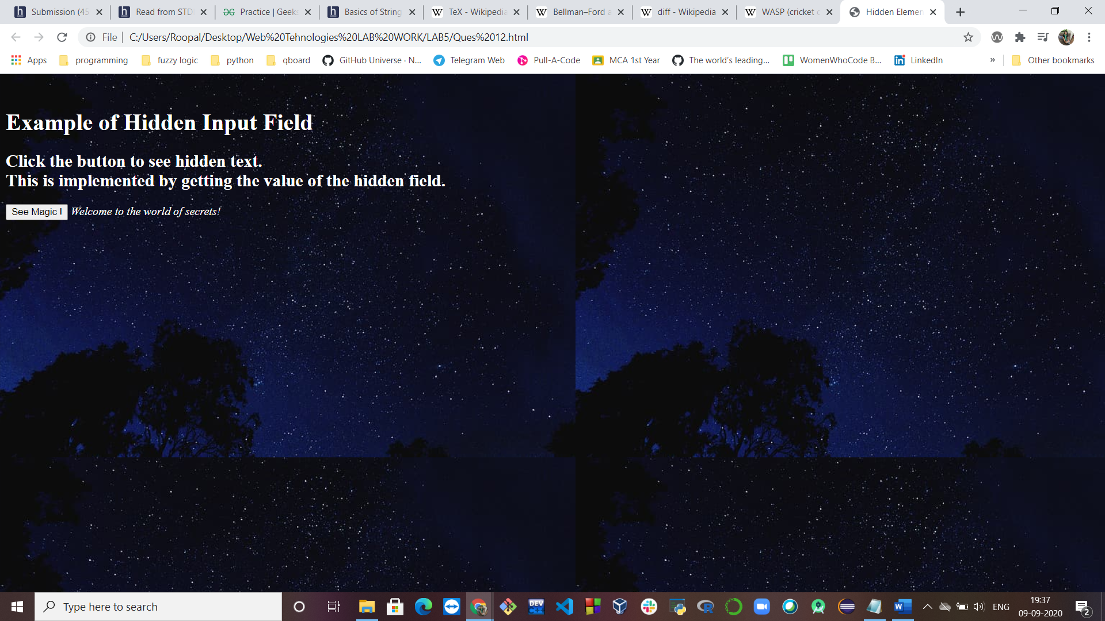

**Ques 13: Write a JavaScript code to perform the following using Cookies:**

* **Create Cookie**
* **Read Cookie**
* **Delete Cookie**

**HTML Code:**

<html>

<head>

<title>Cookies</title>

<script src="Ques 13.js"></script>

</head>

<body bgcolor="LightPink">

<b><h1>Creating, reading and deleting COOKIES</h1></b>

<form name = "myform" action = "">

Enter name: <input type = "text" name = "customer"/>

<input type = "button" value = "Create Cookie" onclick = "WriteCookie();"/>

<br><br>

Click the button and see the result:

<input type = "button" value = "Read Cookie" onclick = "ReadCookie()"/>

<br><br>

Enter name: <input type = "text" name = "customer"/>

<input type = "button" value = "Delete Cookie" onclick = "DeleteCookie()"/>

</form>

</body>

</html>

**JS Code:**

function WriteCookie() {

if( document.myform.customer.value == "" ) {

alert("Enter some value!");

return;

}

cookievalue = escape(document.myform.customer.value) + ";";

document.cookie = "name=" + cookievalue;

document.write ("Setting Cookies : " + "name=" + cookievalue );

}

function ReadCookie() {

var allcookies = document.cookie;

document.write ("All Cookies : " + allcookies );

// Get all the cookies pairs in an array

cookiearray = allcookies.split(';');

// Now take key value pair out of this array

for(var i=0; i<cookiearray.length; i++) {

name = cookiearray[i].split('=')[0];

value = cookiearray[i].split('=')[1];

document.write ("Key is : " + name + " and Value is : " + value);

}

}

function DeleteCookie() {

var now = new Date();

now.setMonth( now.getMonth() - 1 );

cookievalue = escape(document.myform.customer.value) + ";"

document.cookie = "name=" + cookievalue;

document.cookie = "expires=" + now.toUTCString() + ";"

document.write("Deleting Cookies : " + "name=" + cookievalue );

}

**Output:**

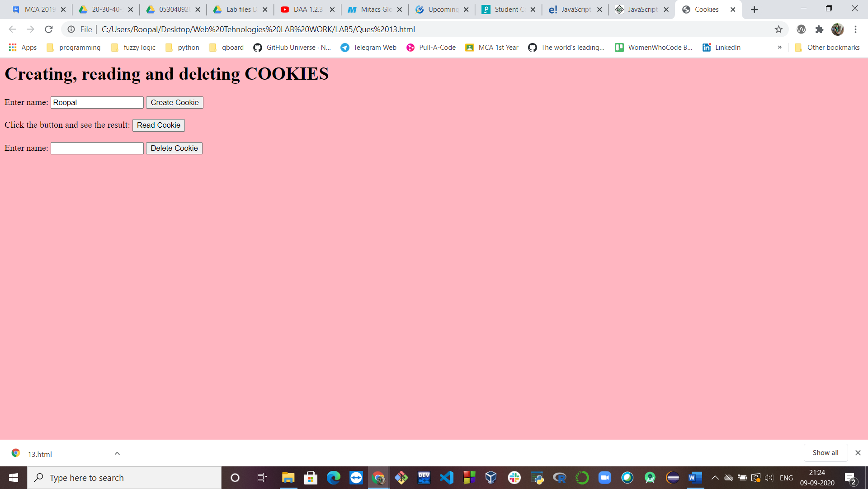

**On click Read Cookie**

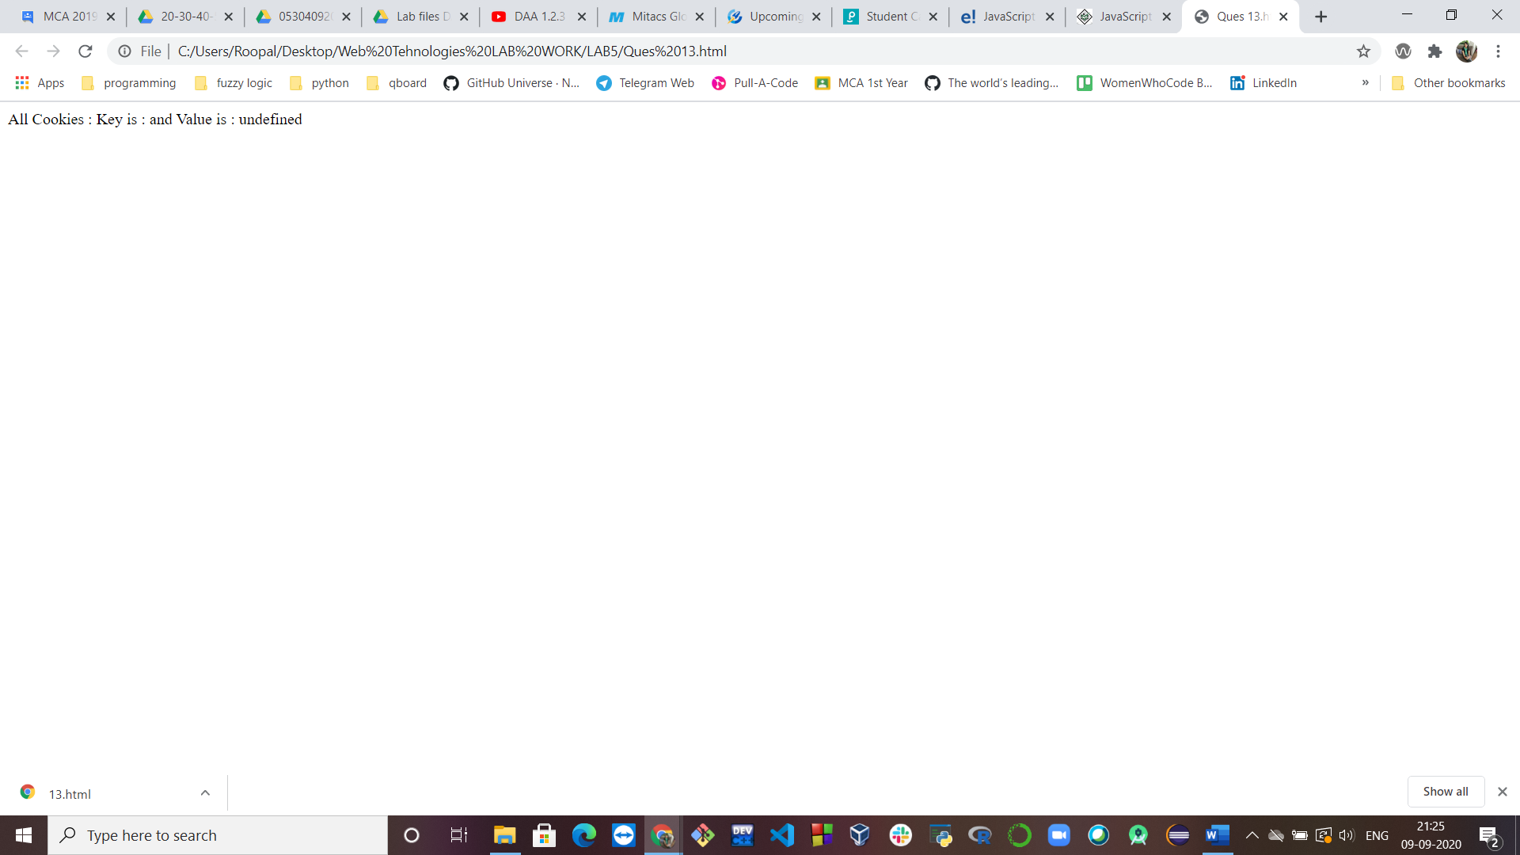

**Ques 14:  Perform following validations using JavaScript:**

1. **Validate the numeric input of data on a text box.**

**HTML + JS Code:**

<html>

<head>

<title>

Number validation using javascript

</title>

<style>

p{color: Red;}

</style>

</head>

<body bgcolor="LightGray">

<h2>Enter a number: </h2>

<p>(Any other alphabet or special character cannot be entered)</p>

<input type="text" id="tbNumbers" value=""

onkeypress="javascript:return isNum(event)"/>

<button type="submit">Submit</button>

</body>

<script>

function isNum(event){

var key = (event.which)? event.which : event.key

if(key != 46 && key > 31 && (key < 48 || key >57))

return false;

return true;

}

</script>

</html>

**Output:**

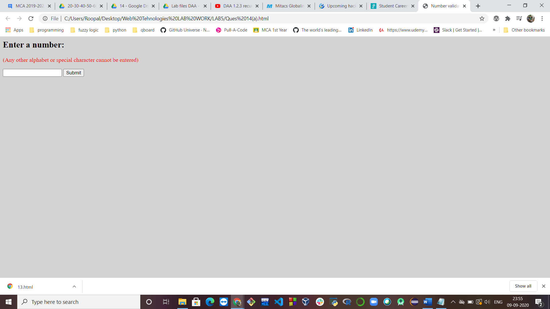

1. **If any field is empty then an alert message should get displayed.**

**HTML Code:**

<html>

<head>

<title>Checking non empty field</title>

<script src="Ques14(b).js"></script>

<style>

h6{color:Red;}

</style>

</head>

<body bgcolor= "LightGreen">

<h3>Enter Student Name:</h3>

<form name="form1" action="#" onsubmit="required()">

<input type='text' name ='text1'/>

<h6>*Required field</h6>

<input type="submit" name="Submit" value="Submit"/>

</form>

</body>

</html>

**JS Code:**

function required()

{

var emp = document.forms["form1"]["text1"].value;

if(emp == ""){

alert("Input a value, field cannot be empty");

return false;

}

else{

alert("value accepted");

return true;

}

}

**Output:**

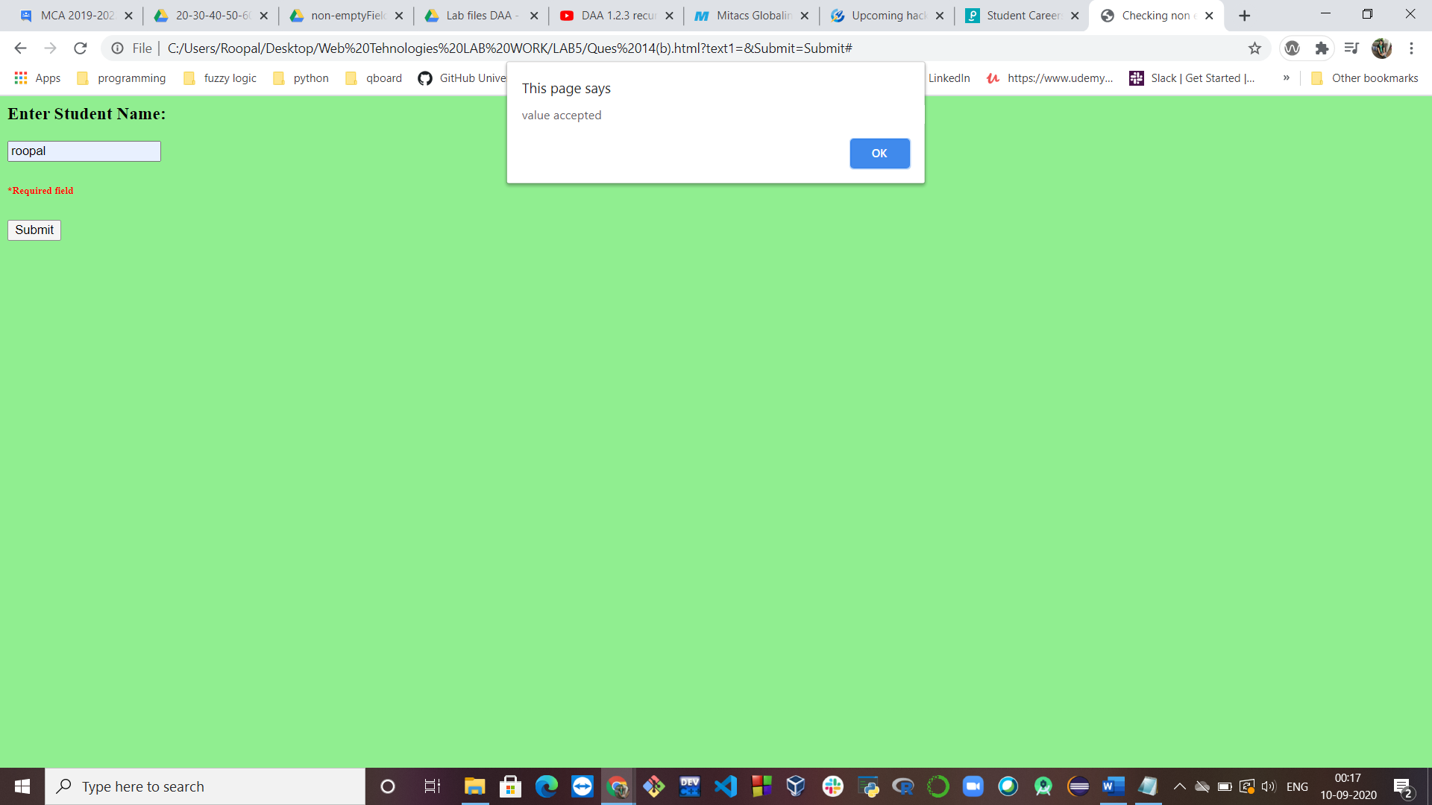

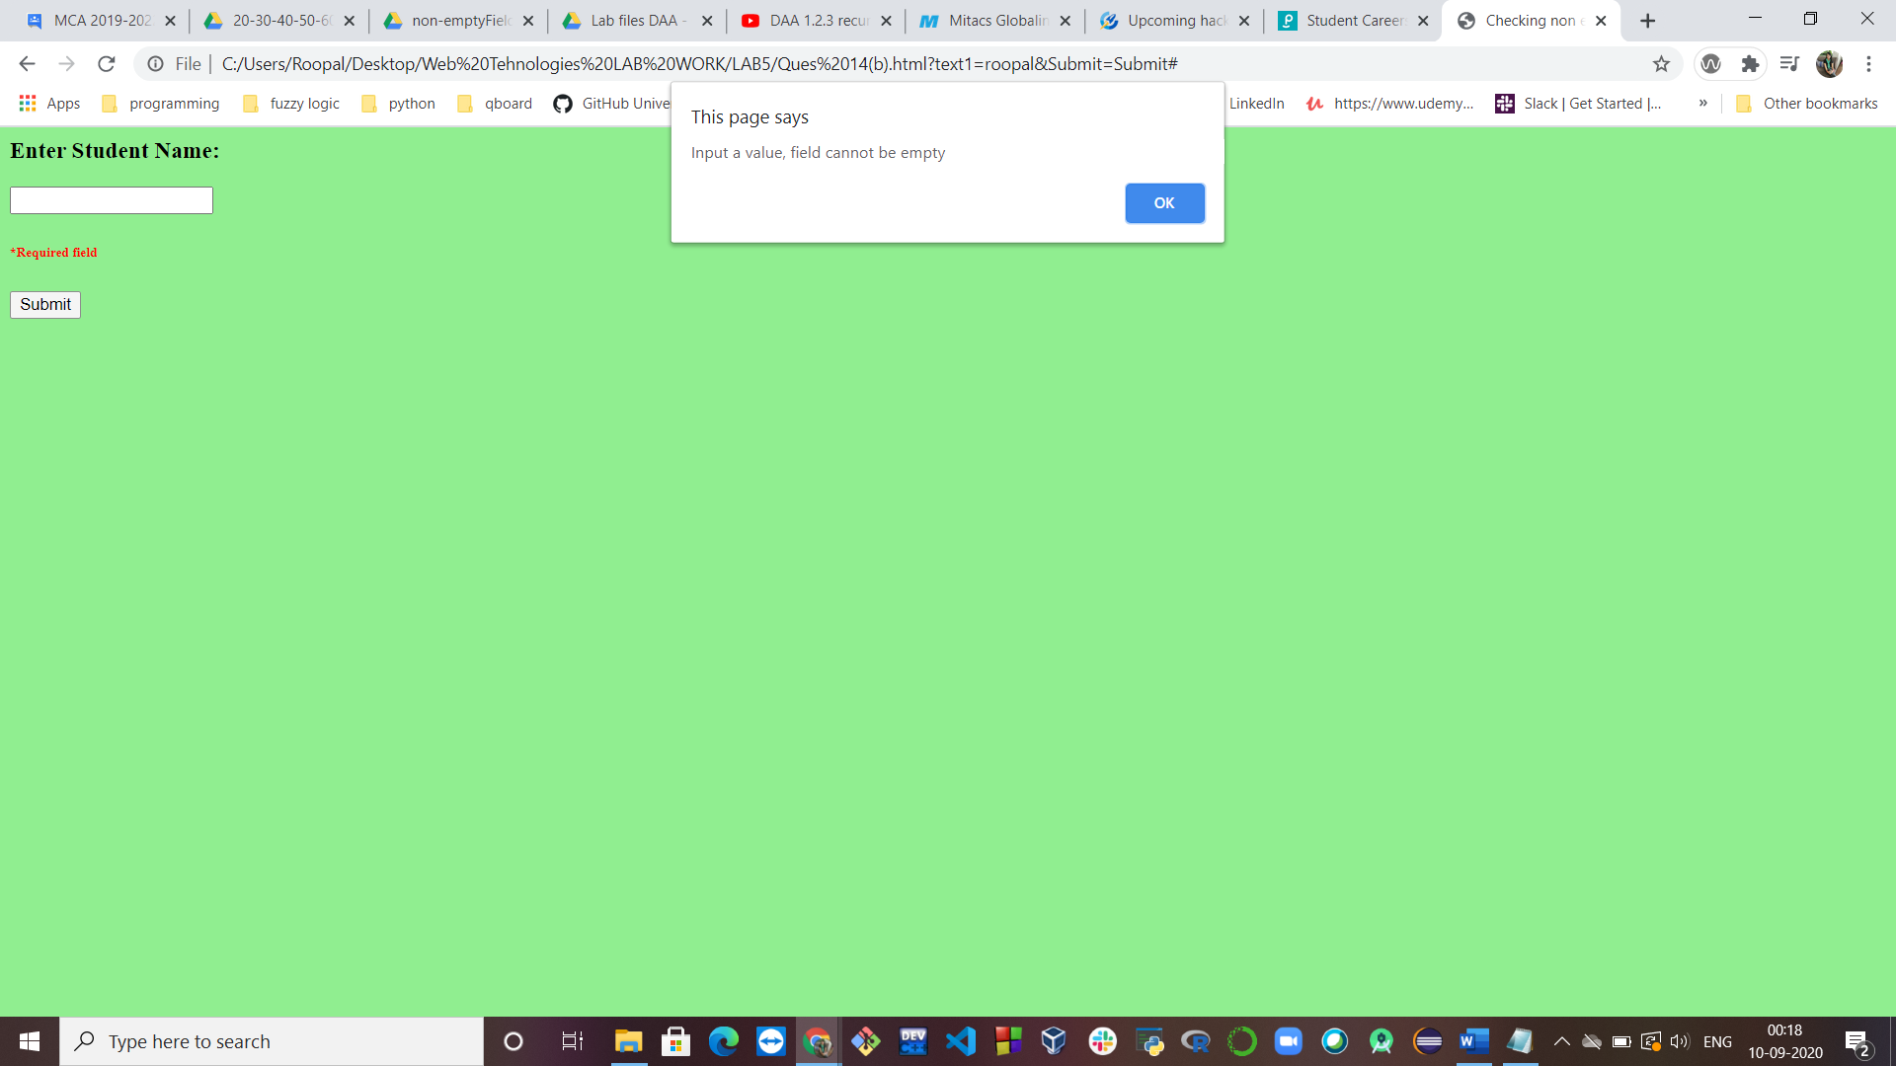

1. **Date format validations.**

**HTML Code:**

<html>

<head>

<title>

JavaScript form validation - checking date

</title>

<script src="Ques14(c).js"></script>

</head>

<body bgcolor="#FAF165" onload='document.form1.text1.focus()'>

<h2>Input a valid date<br>

[dd/mm/yyyy or dd-mm-yyyy format]</h2>

<form name="form1" action="#">

<input type='text' name='text1'/>

<input type="submit" name="submit" value="Submit" onclick="validatedate(document.form1.text1)"/>

</form>

</body>

</html>

**JS Code:**

function validatedate(inputText)

{

var dateformat = /^(0?[1-9]|[12][0-9]|3[01])[\/\-](0?[1-9]|1[012])[\/\-]\d{4}$/;

// Match the date format through regular expression

if(inputText.value.match(dateformat))

{

document.form1.text1.focus();

//Test which seperator is used '/' or '-'

var opera1 = inputText.value.split('/');

var opera2 = inputText.value.split('-');

lopera1 = opera1.length;

lopera2 = opera2.length;

// Extract the string into month, date and year

if (lopera1>1)

{

var pdate = inputText.value.split('/');

}

else if (lopera2>1)

{

var pdate = inputText.value.split('-');

}

var dd = parseInt(pdate[0]);

var mm = parseInt(pdate[1]);

var yy = parseInt(pdate[2]);

// Create list of days of a month [assume there is no leap year by default]

var ListofDays = [31,28,31,30,31,30,31,31,30,31,30,31];

if (mm==1 || mm>2)

{

if (dd>ListofDays[mm-1])

{

alert('Invalid date format!');

return false;

}

}

if (mm==2)

{

var lyear = false;

if ( (!(yy % 4) && yy % 100) || !(yy % 400))

{

lyear = true;

}

if ((lyear==false) && (dd>=29))

{

alert('Invalid date format!');

return false;

}

if ((lyear==true) && (dd>29))

{

alert('Invalid date format!');

return false;

}

}

}

else

{

alert("Invalid date format!");

document.form1.text1.focus();

return false;

}

}

**Output:**

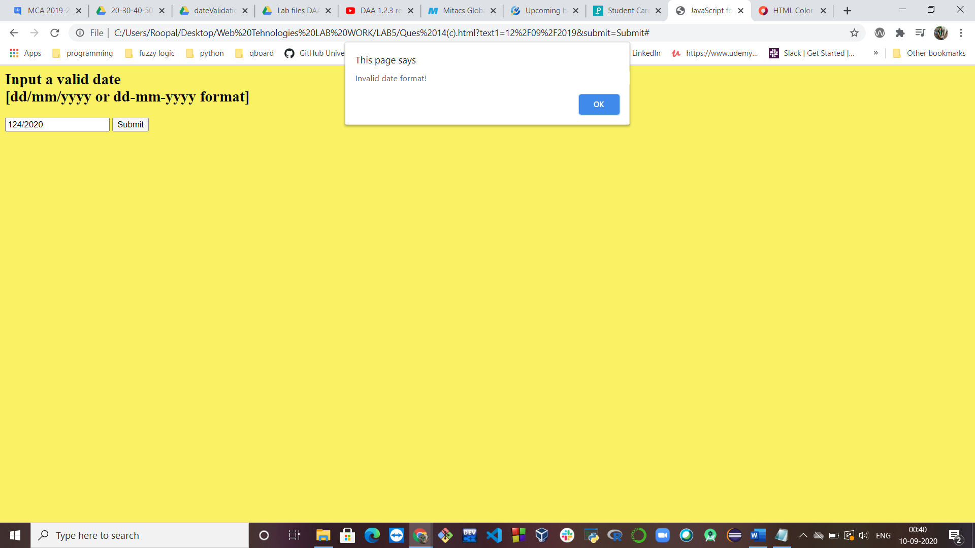

1. **E-mail format validations.**

**HTML Code:**

<html>

<head>

<title>JavaScript form validation - checking email</title>

<script src="Ques14(d).js"></script>

</head>

<body bgcolor="#E4FE8C" onload='document.form1.text1.focus()'>

<h2>Enter E-mail and Submit</h2>

<form name="form1" action="#">

<input type='text' name='text1'/></li>

<input type="submit" name="submit" value="Submit" onclick="ValidateEmail(document.form1.text1)"/>

</form>

</body>

</html>

**JS Code:**

function ValidateEmail(inputText)

{

var mailformat = /^\w+([\.-]?\w+)*@\w+([\.-]?\w+)*(\.\w{2,3})+$/;

if(inputText.value.match(mailformat))

{

document.form1.text1.focus();

return true;

}

else

{

alert("You have entered an invalid email address!");

document.form1.text1.focus();

return false;

}

}

**Output:**

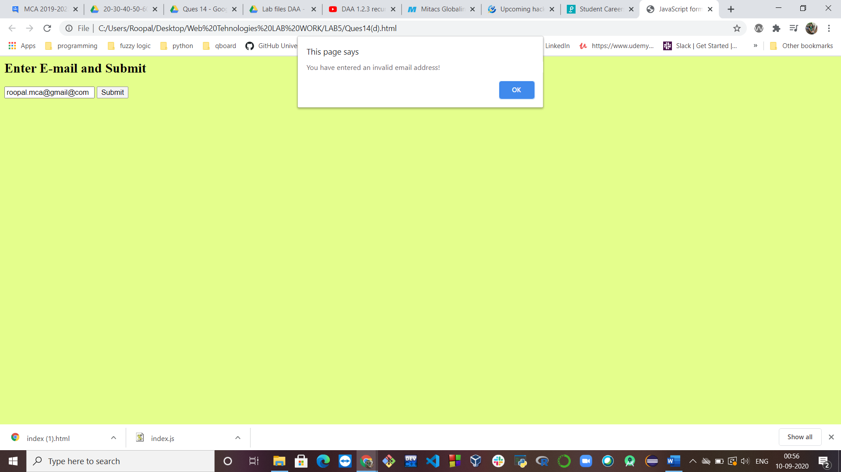

**Ques 15: Create an XML document as shown below and add CSS for styling and DTD for validation.**

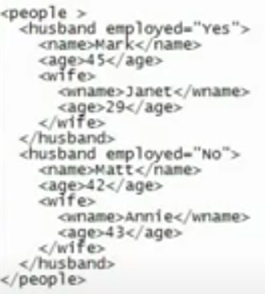

**XML Code:**

<?xml version="1.0" encoding="UTF-8"?>

<?xml-stylesheet type="text/css" href="document.css"?>

<!DOCTYPE note SYSTEM "document.dtd">

<people>

<husband employed="Yes">

<name>Mark</name>

<age>45</age>

<wife>

<wname> Janet</wname>

<age>29</age>

</wife>

</husband>

<husband employed="No">

<name>Matt</name>

<age>42</age>

<wife>

<wname>Annie</wname>

<age>43</age>

</wife>

</husband>

</people>

**CSS Code:**

husband

{

font-family: sans-serif;

color: hotpink;

background-color: black;

}

name

{

color: red;

}

wife

{

color: aqua

}

**DTD Code:**

<!DOCTYPE people

[

<!ELEMENT people (husband, name, age, wife)>

<!ELEMENT husband (#PCDATA)>

<!ELEMENT name (#PCDATA)>

<!ELEMENT age (#PCDATA)>

<!ELEMENT wife (wname, age)>

<!ELEMENT wname (#PCDATA)>

<!ELEMENT age (#PCDATA)>

]>